|  |  |
| --- | --- |
| **Full Name** | **Muhammad Afzal** |
| **Batch** | **MS FSD DEC 2021 Cohort 1** |
| **Student ID** | **Afzal** |
| **Project Title** | **CI/CD Deployment for Springboot Application.** |
| **Project Submission Date** | **August 26, 2022** |

# Main Project Structure

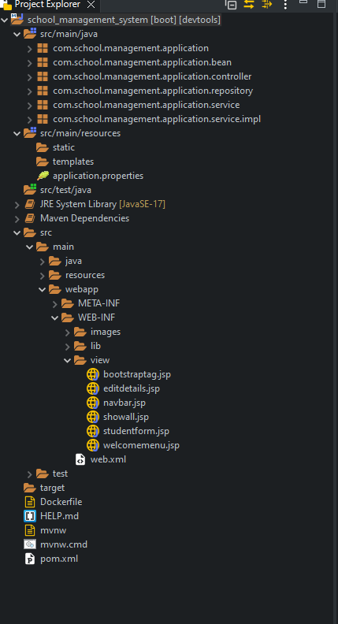

# Open CMD and Pull mysql

docker pull mysql:latest

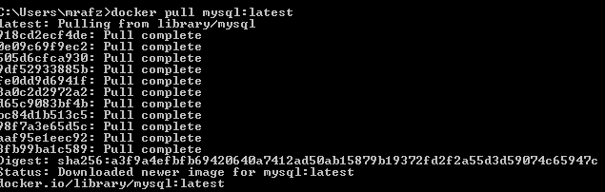

# Run image

docker run --name docker-mysql -e MYSQL_ROOT_PASSWORD=password -e MYSQL_DATABASE=schoolmanage -e MYSQL_USER=user -e MYSQL_PASSWORD=password -d mysql:latest --default-authentication-plugin=mysql_native_password

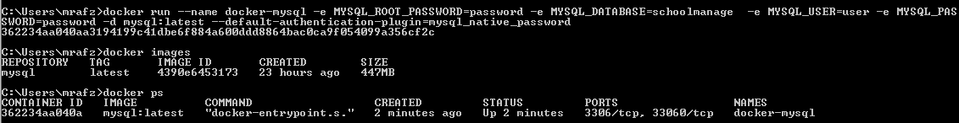

# Open Command Prompt in Project file Directory

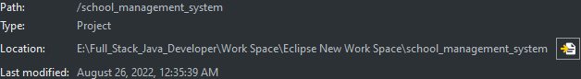

# Create an Image

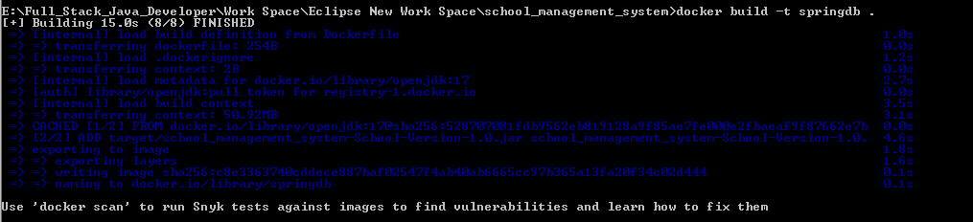

# Use Images and Run app on port 8094 port number mentioned in docker

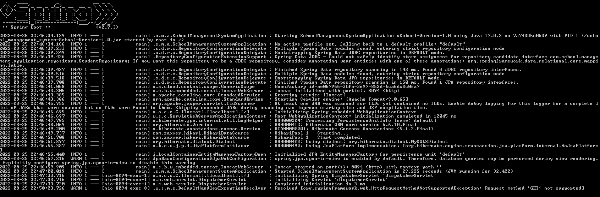

|  |
| --- |
| Main |
|  |
| Add New Student    Fetch all Student  Display All Student  Edit Update Student:  New Data  New Student Updated  Delete Student 5  Deleted Student |

**Thank you**